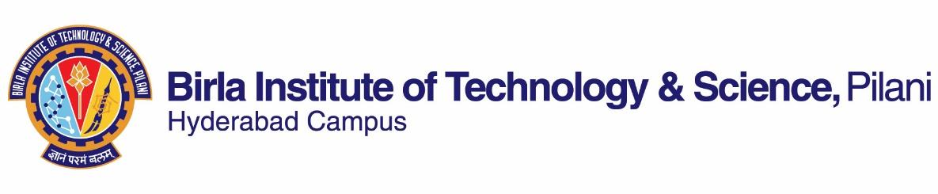

**INSTRUCTION DIVISION**

**FIRST SEMESTER 2019-2020**

# Course Handout Part II

Date: 10-01-2020

1. **Course Number: HSS F266**
2. **Course Title: Study Project**
3. **Instructor IC: Aswathy Raveendran**

Room No. K 106, Department of Humanities and Social Sciences,

BITS Pilani, Hyderabad Campus

1. **COURSE DESCRIPTION**

The project type course is aimed at developing the ability of the student to explore a specific humanities or social science research problem with considerable rigor and criticality. Each project requires the student to search for relevant literature, develop a broad understanding of the issues involved and build their skills in summarizing their learnings in the form of mid-semester and final report and seminar presentation. Overall, the course would require significant amount of reading and reflection on a particular topic. It is essential that students interact with their respective supervisors at periodic intervals throughout the study to facilitate significant learning.

1. **Evaluation Scheme:**

|  |  |  |
| --- | --- | --- |
| **EC No.** | **Evaluation Component (EC)** | **Weightage** |
| 1. | Plan of Work  Seminar I  Mid Sem. Report  Mid Sem. Seminar | 10  10  10  15 |
| 2 | Final Report  Final Seminar  Weekly Interaction | 25  20  10 |

1. **Course Notices:** Notices, if any, will be displayed on CMS.
2. **Plagiarism**: Mid Sem. and Final Report are to be submitted with complete Turnitin report and its acknowledgement receipt.
3. **Academic Honesty and Integrity Policy**: Academic honesty and integrity are to be maintained by all the students throughout the semester and no type of academic dishonesty is acceptable.

**Aswathy Raveendran**

**INSTRUCTOR-IN-CHARGE**